Case 3-A337-Asia-Pakistan-Peshawar-Avalokiteśvara-Schist-Kushan-4th c CE

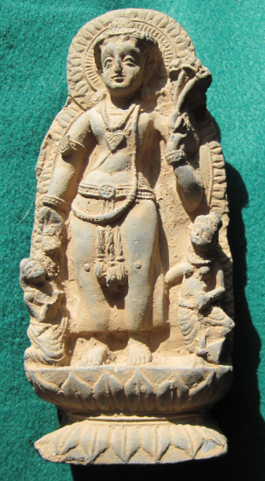

Fig. 1. Asia-Pakistan-Peshawar-Avalokiteśvara-Schist-Kushan-4th c CE

**Case no.: 3**

**Accession Number: A337**

**Formal Label:** Asia-Pakistan-Peshawar-Avalokiteśvara-Schist-Kushan-4th c CE

**Display Description:**

The Kushan Period art of Gandhara in Peshawar Valley flourished by commemorating the Jatakas during the reign of king Kanishka the Great (128–151 AD/CE), when the cities of Taxila (Takṣaśilā) at Sirsukh and the capital at Peshawar were built. Kanishka as a patron of Buddhism helped diffuse the religion to Central Asia and the Far East across Bactria and Sogdiana (now Xinxiang Province), where his empire intersected with the Han Empire of China. This attracted Chinese pilgrims to worship at Buddhist monuments along the Silk Road. Mahayana Buddhism represented the Buddha in human form and many new sculptures of the Buddha were carved and new stupas and painted and sculptured caves were built while others were enlarged.

This particular sculpture is culturally important in that it shows Avalokiteśvara with Hellenistic style folded robes as well as open eyes so characteristic of Greek deities and this offers a glimpse of a Greek woman who was accompanying Alexander’s troops who posed for this sculpture. The sculptor was obviously inexpert at carving the correct mudra of the hands so he left them in an unidentifiable pose, which suggests he was a Greek sculptor.

**LC Classification**: [NB992.2.K36](http://josiah.brown.edu/search~S7?/c2-SIZE+NB992.2.K36+B87+1978/cnb++992.2+k36+b87+1978/-3%2C-1%2C0%2CE/frameset&FF=cnb++992.2+k36+b87+1978&1%2C1%2C)

**Date or Time Horizon:** Kushan Period-4th Century

**Dimensions:** H 162.18 mm; 6.39 in.

**Weight: 411 gm; 14 3/8 oz.**

**Condition: original**

**Provenance:** unknown

**Discussion:**

**References:**

Allchin, Bridget and Raymond Allchin. 1988. *The rise of civilization in India and Pakistan.* Cambridge: Cambridge University Press.

Allchin, F. Raymond. 1993. "The Urban Position of Taxila and Its Place in Northwest India-Pakistan," *Studies in the History of Art*, 31: 69–81.

Cunningham, Alexander. 1871. *The Ancient Geography of India: The Buddhist Period, Including the Campaigns of Alexander, and the Travels of Hwen-Thsang*. Cambridge: Cambridge University Press.

Marshall, John. 1960. *A guide to Taxila* (4th ed.). Cambridge: Cambridge University Press.

Marshall, John. 1951. *Taxila: an illustrated account of archaeological excavations carried out at Taxila under the orders of the Government of India between the years 1913 and 1914*. 3 v. Delhi: Barnasidass